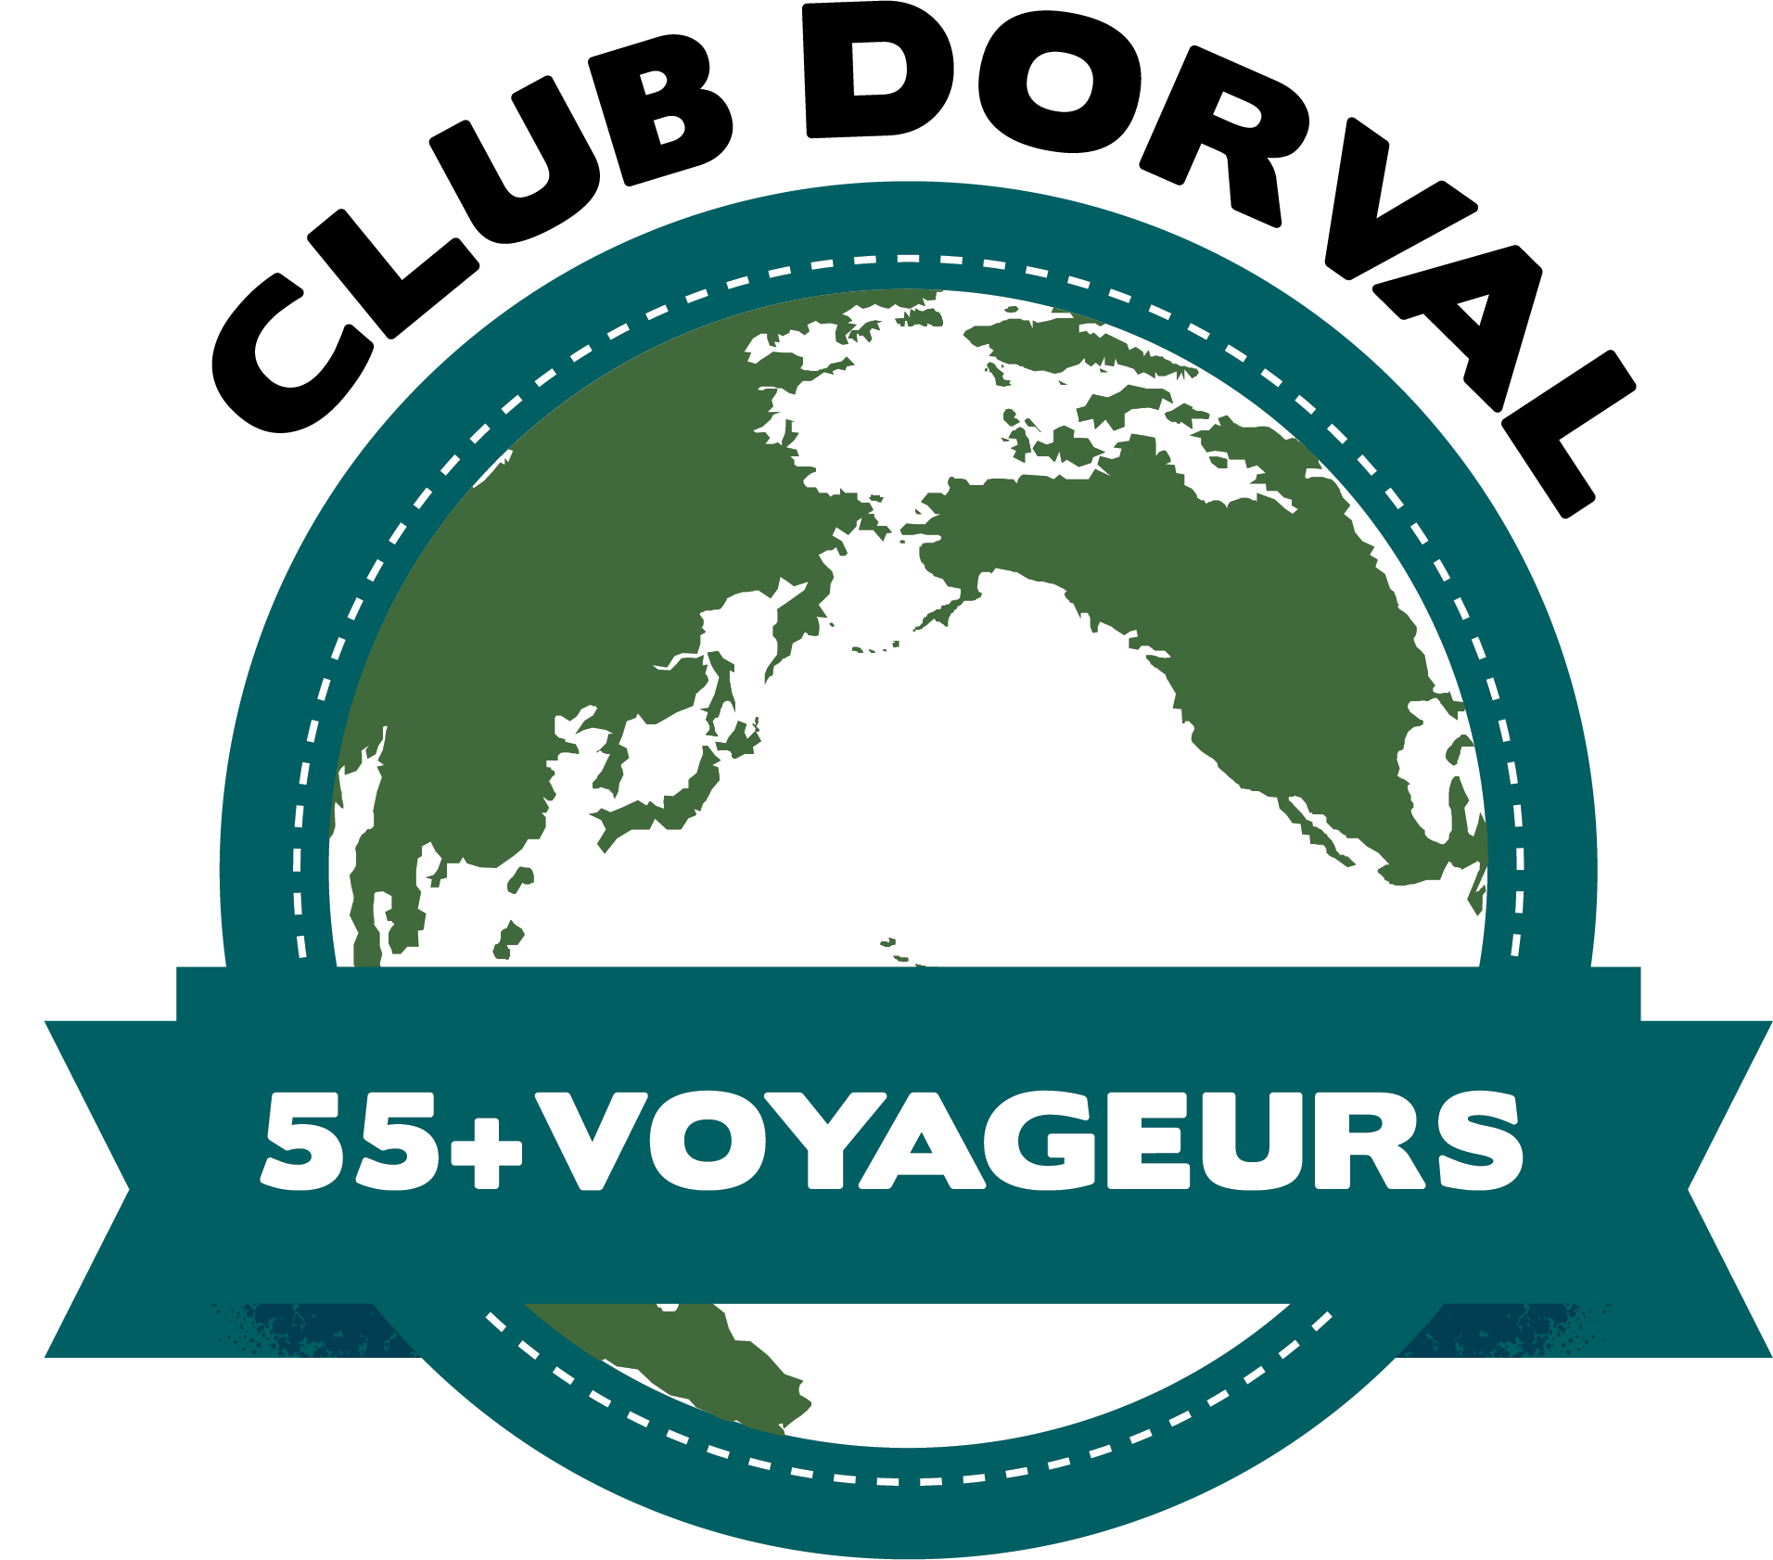
QUEBEC AND NEWFOUNDLAND ADVENTURE

WINDSTAR CRUISE

SEPT. 25 – OCT. 9, 2026

INFORMATION SESSION WITH CHRIS LATREMOILLE OF UNIGLOBE TRAVEL

WHERE: Sarto Desnoyers Community Centre, 1335 Lakeshore, Dorval

DATE: Thursday, January 8, 2026

TIME: 10 a.m.

You are invited to a meeting to learn more about this great cruise. You will have the opportunity to make your deposits; so bring your cheques or credit cards. Please see the information below for more details of the trip. You can also check the Windstar website.

Trip Directors: Rosemary Leaver: 514-636-4507 Pat Murray: 514-592-2286

****WINDSTAR STAR PRIDE****
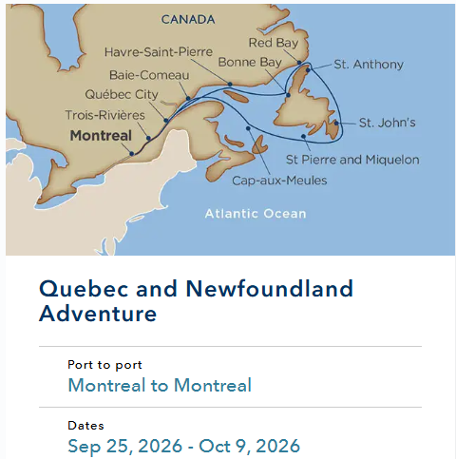

Always Included Complimentary
• Open dining with no reservation fees required
• Non-alcoholic beverages, including coffee, tea and soda
• Beautifully appointed ocean-view staterooms and suites
• Plush bathrobes and slippers
• Fresh flowers and fruit in your stateroom or suite
• Flat-screen TV
• Signature onboard deck barbecue*
• Onboard entertainment, including local performances in most regions
• 24-hour Room service
• Fully equipped Watersports Platform and use of all water sports equipment*
• Access to the Open Bridge
• Champagne welcome reception
• Signature Sail Away event from every port*
• Access to WorldSpa by Windstar sauna/steam room facilities, yoga and Pilates

Optional: All Inclusive rates – include Wi-Fi, unlimited select beer, wine & cocktails, and gratuities.

STATEROOMS:
STAR PORTHOLE SUITE – 277 SQ. FT – Queen bed can be split into 2 doubles
Single Occupancy – $20,413 CAD or All Inclusive, $21,731.00
Double Occupancy - $10,255 CAD or All Inclusive, $10,914
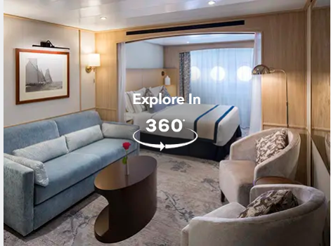

OCEAN VIEW SUITE 1 – 277 sq ft – Ocean View
Single Occupancy – $21,573 CAD or All Inclusive, $23,315.00
Double Occupancy - $10,835 CAD or All Inclusive, $11,706.00

